**CC-215-L: Database Systems Lab**



**BS(CS) Morning - Fall 2021, Semester Fall 2023**

**LAB – 04**

# Topics

* Single row functions (Revision)
* Decode
* Case
* Group Functions
* Group By Clause
* Having clause
* Revision from last Lab

# Learning Objectives

* Revising the Concepts about Single Row Functions and their usage
* Performing Expression Conditions using Decode
* Performing Expression Conditions using Case
* Learning Group By clause to Grouping the Columns based on conditions
* Learn to use Having Clause
* Revision of Concepts' from Previous Labs

# General Instructions:

* In this Lab, you are **NOT** allowed to discuss your solution with your colleagues, even not allowed to ask how s/he is doing; this may result in negative marking. You can **ONLY** discuss with your Teaching Assistants (TAs) or Lab Instructor.
* Your TAs will be available in the Lab for your help. Alternatively, you can send your queries via email to one of the followings.

|  |  |  |
| --- | --- | --- |
| **Lab Instructors** | | |
| Course Instructor | Dr. Asif Sohail | [asif@pucit.edu.pk](mailto:asif@pucit.edu.pk) |
| Teaching Assistants | Kabeer Ali | [bitf20m018@pucit.edu.pk](mailto:bitf20m018@pucit.edu.pk) |
| Hamza Farooqi | [bitf20m031@pucit.edu.pk](mailto:bitf20m018@pucit.edu.pk) |

Hope you are fine and feeling yourself comfortable and exciting to play with Structured Query Language (SQL) in this first lab. *You have been taught in the lecture about SQL and query writing. Why not to get all what you have learned with a hands-on experience?* So, let’s Start!

*Allowed time: 1.5 hour*

***Note: Do follow these instructions while you are sitting in the lab and performing the tasks.***

1. ***Gossips are not allowed. So be gentle and do what you know. The lab is not to deduct your sessional marks but to prepare you to achieve good marks in quizzes, mids and finals and finally have good grades. So, try to perform all your tasks in time and at your own.***
2. ***Teacher assistants are for your help, so be nice with them. Respect them as they are teaching you. Raise your hands if you have some problem and need help from TA. Avoid calling them by raising your voice and disturbing the environment of Lab.***
3. ***You must revise the content of the past lectures before starting the lab, it will help you resolve most of your general queries and give you the confidence that you can do it.***
4. ***Evaluation will be considered final and you cannot debate for the marks. So, focus on performing the tasks when the time is given to you.***
5. ***TA may deduct your marks for any kind of ill-discipline or misconduct from your side.***
6. ***Finally, pray before you start. And, Best of Luck!***

* **Kindly paste the query as well as result table screenshot as a result of each task**

**Sample:**

**Display All the Employees from emp table**

**Solution:**

**Select * from emp**

|  |  |  |  |  |  |  |  |
| --- | --- | --- | --- | --- | --- | --- | --- |
| **EMPNO** | **ENAME** | **JOB** | **MGR** | **HIREDATE** | **SAL** | **COMM** | **DEPTNO** |
| 7369 | SMITH | CLERK | 7902 | 12/17/1980 | 800 | - | 20 |
| 7499 | ALLEN | SALESMAN | 7698 | 02/20/1981 | 1600 | 300 | 30 |
| 7521 | WARD | SALESMAN | 7698 | 02/22/1981 | 1250 | 500 | 30 |
| 7566 | JONES | MANAGER | 7839 | 04/02/1981 | 2975 | - | 20 |
| 7654 | MARTIN | SALESMAN | 7698 | 09/28/1981 | 1250 | 1400 | 30 |

**Task 01: [15 Marks]**

1. Display the employees name who joined in the month having at least one ‘a’ letter in it , make sure to add an asterisk( * ) on both sides of the employee name if length of name is less than 5.
2. Display the first half of the ‘Department Name’. (If the length of dname is odd display half+1)
3. The organization has decided to award bonus to its employees. The bonus equals the average salary of all the employees. Display the empno, ename, sal, bonus, and net salary of all the employees. Round the bonus, and net salary to 2 decimal places.
4. List the employees with salary greater than 2100 but should not be a manager or president.
5. Take last 2 digit from salary and first 5 letters from jobs and in between these add “TA” ,make sure these are seprated by a hyphen (-) i.e 00-CLERK-TA
6. Extract the Last Name of the student from Pucit Table.
7. List all the employees hired in leap years.
8. Display all the employees whose salary is a three-digit number, ending with zero.
9. Find sum , average of salaries for each department excluding where the job is manager.
10. Find Maximum paid employee name from each department whose name starts with K.
11. Display the count of A and T in the ename of employees, and sum of their count.
12. Display the ename, sal, stars using the EMP table. The stars column should display the ename with trailing stars equal to the number of digits of the sal of the employee.
13. Extract the Names , department numbers of the most senior, and the most junior employees.
14. Display the names, job and commission of all the employees who are Clerk, Analyst or Salesman. **(Using single condition)**
15. Suppose that all the employees are hired on three months’ probation period. After which, the employees are confirmed on their jobs. Display empno, ename, hiredate, and confirmation date of all the employees.

**Task 02: [20 Marks]**

1. Identify the managers who have at least one employee working for them
2. Show the total number of jobs in each department in which employees are working.
3. Write a query to display job and the number of people with the same job.
4. Write a query to display the date of the first Monday of the current month.
5. List jobs where the total commission earned is greater than 1000
6. Count the number of employees in each job category and display only those job categories with more than 5 employees.
7. Identify employees with duplicate names and display the name along with the count of occurrences. Show only names that occur more than once.
8. Prepare a year-wise hiring report of the employees. The report should display the year, and the count of employees hired in the given year for those years where the count is greater than 3.
9. Display the maximum salary for each department, but only for departments with more than two employees
10. List the departments where the total commission earned is greater than the total salary paid

**Task 03: [15 Marks]**

1. Write a query using DECODE to display the job title as 'Manager' if an employee is a manager and 'Employee' otherwise.
2. Write a SQL query that categorizes employees based on their job and salary conditions using the DECODE function. The categorization should include distinctions for Managers, Low-Paid Clerks (if salary<1000), High-Paid Clerks (if salary>1100), SALESMAN with commission, SALESMAN without commission, and others. Provide the employee number (empno), name (name), job (job), salary (salary), and the newly created column job_category in the result set. Adjust the conditions in the DECODE function as needed based on the specified criteria to make My_Made_Catogory

**(5 Marks)**

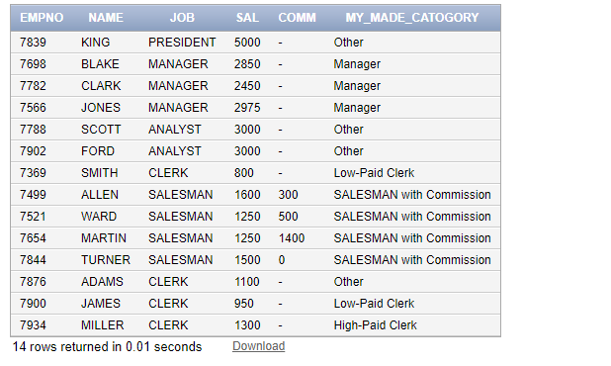

1. Write a query to display name, hiredate, service time (in years), status of employees. The service time should be rounded. Status will be "Category-A", if the years of service is greater than 42. Otherwise, the status will be "Category-B".

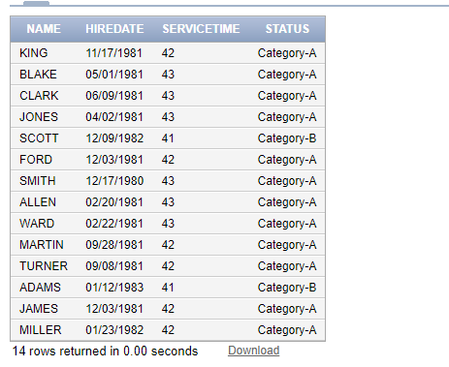

1. Display employee names, jobs, and a new column "Performance" based on their salaries using CASE.

SAL > 4000, 'High Performance',

SAL > 2500, 'Medium Performance',

SAL <= 2500, 'Low Performance'

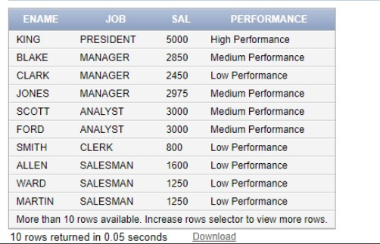

1. Categorize employees based on their tenure: 'Data Sample A' for those hired in the l983, 'Data Sample B' for those hired in 1981 or 1982, and 'Data Sample C' for those hired in 1980 using CASE.

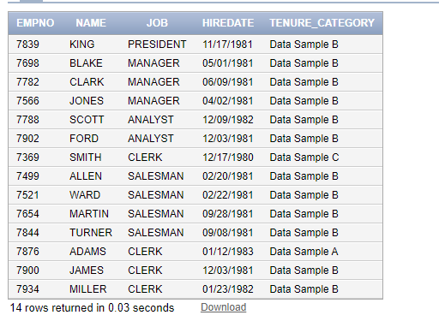

**Task 04: [5 Marks]**

**Viva-Voce.**